Project Report
Roll No:24141030 Lab: PL-II

Typing Speed Test Application - Mini Project

Project Overview
This is a complete mini-project suitable for your Python experiments portfolio. I'll provide you with Theory, Complete Code, and Explanation for a Typing Speed Test Application.

Theory
1. Introduction to Typing Speed Test Application
A Typing Speed Test Application is a program that measures how fast and accurately a user can type. It presents a sample text to the user, records the time taken to type it, and calculates metrics like Words Per Minute (WPM) and accuracy percentage.

2. Project Objectives
Objective | Description
GUI Development | Create user-friendly interface using Tkinter
Timer Functionality | Measure typing speed accurately
Text Comparison | Compare user input with original text
Performance Metrics | Calculate WPM, accuracy, and errors
Data Persistence | Save and display high scores

3. Key Concepts Used
Concept | Application in Project
Tkinter GUI | Window, labels, buttons, text widgets
Time Module | Calculate typing duration
String Operations | Compare texts, count characters/words
File Handling | Save high scores and load sample texts
Event Handling | Button clicks, timer updates
Object-Oriented Programming | Class structure for the application

4. Formula Used
Words Per Minute (WPM):
text
WPM = (Total Characters Typed / 5) / (Time in Minutes)
Accuracy Percentage:
text
Accuracy = (Correct Characters / Total Characters in Original) × 100

Code:
import tkinter as tk
from tkinter import messagebox, ttk
import time
import random
import json
import os
from datetime import datetime

class TypingSpeedTest:
"""Main application class for Typing Speed Test"""

def __init__(self, root):
"""Constructor - Initialize the application"""
self.root = root
self.root.title("Typing Speed Test Application")
self.root.geometry("900x700")
self.root.configure(bg="#2c3e50")

self.sample_text = ""
self.user_input = ""
self.start_time = 0
self.end_time = 0
self.timer_running = False
self.time_left = 60 # 60 seconds default
self.total_time = 60
self.high_scores = []

# Load sample texts and high scores
self.load_sample_texts()
self.load_high_scores()

# Create GUI elements
self.create_widgets()

# Select random text to start
self.select_random_text()

def load_sample_texts(self):
"""Load sample texts for typing test"""
self.sample_texts = {
"Easy": [
"The quick brown fox jumps over the lazy dog.",
"Python is a great programming language for beginners.",
"Practice makes perfect when learning to type faster.",
"The sun rises in the east and sets in the west.",
"Coding is fun and helps solve real world problems."
],
"Medium": [
"Artificial intelligence is transforming the way we live and work in modern society.",
"The development of quantum computing could revolutionize science and technology.",
"Learning to type quickly requires consistent practice and proper finger placement.",
"Programming languages like Python and JavaScript are widely used in industry.",
"The Internet of Things connects everyday devices to the digital world."
],
"Hard": [
"Machine learning algorithms enable computers to learn from data without being explicitly programmed for specific tasks, making them invaluable for complex problem-solving scenarios.",
"Blockchain technology provides a decentralized and secure method for recording transactions across multiple computers, ensuring transparency and preventing data tampering.",
"Cloud computing offers on-demand access to computing resources including servers, storage, databases, networking, and software over the internet with pay-as-you-go pricing."
]
}

def load_high_scores(self):
"""Load high scores from file"""
try:
if os.path.exists("typing_scores.json"):
with open("typing_scores.json", "r") as f:
self.high_scores = json.load(f)
else:
self.high_scores = []
except Exception as e:
print(f"Error loading scores: {e}")
self.high_scores = []

def save_high_scores(self):
"""Save high scores to file"""
try:
# Keep only top 10 scores
self.high_scores.sort(key=lambda x: x['wpm'], reverse=True)
self.high_scores = self.high_scores[:10]
with open("typing_scores.json", "w") as f:
json.dump(self.high_scores, f, indent=2)
except Exception as e:
print(f"Error saving scores: {e}")

def create_widgets(self):
"""Create all GUI widgets"""

# Title Frame
title_frame = tk.Frame(self.root, bg="#2c3e50")
title_frame.pack(pady=10)

title_label = tk.Label(title_frame, text="TYPING SPEED TEST ",
font=("Arial", 24, "bold"),
fg="#f1c40f", bg="#2c3e50")
title_label.pack()

subtitle_label = tk.Label(title_frame, text="Test your typing speed and accuracy",
font=("Arial", 12), fg="#ecf0f1", bg="#2c3e50")
subtitle_label.pack()

# Difficulty and Timer Frame
control_frame = tk.Frame(self.root, bg="#2c3e50")
control_frame.pack(pady=10)

# Difficulty selection
tk.Label(control_frame, text="Difficulty:", font=("Arial", 11),
fg="white", bg="#2c3e50").grid(row=0, column=0, padx=10)

self.difficulty_var = tk.StringVar(value="Medium")
difficulty_menu = ttk.Combobox(control_frame, textvariable=self.difficulty_var,
values=["Easy", "Medium", "Hard"], state="readonly")
difficulty_menu.grid(row=0, column=1, padx=10)
difficulty_menu.bind("<<ComboboxSelected>>", self.on_difficulty_change)

# Timer selection
tk.Label(control_frame, text="Time (seconds):", font=("Arial", 11),
fg="white", bg="#2c3e50").grid(row=0, column=2, padx=10)

self.time_var = tk.StringVar(value="60")
time_menu = ttk.Combobox(control_frame, textvariable=self.time_var,
values=["30", "60", "90", "120"], state="readonly")
time_menu.grid(row=0, column=3, padx=10)
time_menu.bind("<<ComboboxSelected>>", self.on_time_change)

# Sample Text Frame
sample_frame = tk.LabelFrame(self.root, text="Type this text:",
font=("Arial", 12, "bold"),
fg="#f1c40f", bg="#34495e", bd=2)
sample_frame.pack(pady=10, padx=20, fill="both")

self.sample_text_widget = tk.Text(sample_frame, height=5, width=80,
font=("Consolas", 12), wrap="word",
bg="#ecf0f1", fg="#2c3e50")
self.sample_text_widget.pack(padx=10, pady=10)
self.sample_text_widget.config(state="disabled")

# User Input Frame
input_frame = tk.LabelFrame(self.root, text=" Type here:",
font=("Arial", 12, "bold"),
fg="#f1c40f", bg="#34495e", bd=2)
input_frame.pack(pady=10, padx=20, fill="both")

self.input_text_widget = tk.Text(input_frame, height=8, width=80,
font=("Consolas", 12), wrap="word",
bg="white", fg="#2c3e50")
self.input_text_widget.pack(padx=10, pady=10)
self.input_text_widget.bind("<KeyRelease>", self.on_key_release)
self.input_text_widget.config(state="disabled")

# Stats Frame
stats_frame = tk.Frame(self.root, bg="#2c3e50")
stats_frame.pack(pady=10)

# Timer display
self.timer_label = tk.Label(stats_frame, text=" Time Left: 60s",
font=("Arial", 16, "bold"),
fg="#e74c3c", bg="#2c3e50")
self.timer_label.grid(row=0, column=0, padx=30)

# WPM display
self.wpm_label = tk.Label(stats_frame, text=" WPM: 0",
font=("Arial", 16, "bold"),
fg="#2ecc71", bg="#2c3e50")
self.wpm_label.grid(row=0, column=1, padx=30)

# Accuracy display
self.accuracy_label = tk.Label(stats_frame, text="Accuracy: 0%",
font=("Arial", 16, "bold"),
fg="#3498db", bg="#2c3e50")
self.accuracy_label.grid(row=0, column=2, padx=30)

# Button Frame
button_frame = tk.Frame(self.root, bg="#2c3e50")
button_frame.pack(pady=15)

self.start_button = tk.Button(button_frame, text="START TEST",
font=("Arial", 12, "bold"),
bg="#27ae60", fg="white",
padx=20, pady=8,
command=self.start_test)
self.start_button.grid(row=0, column=0, padx=10)

self.reset_button = tk.Button(button_frame, text=" RESET",
font=("Arial", 12, "bold"),
bg="#e67e22", fg="white",
padx=20, pady=8,
command=self.reset_test)
self.reset_button.grid(row=0, column=1, padx=10)

self.new_text_button = tk.Button(button_frame, text="📖 NEW TEXT",
font=("Arial", 12, "bold"),
bg="#3498db", fg="white",
padx=20, pady=8,
command=self.select_random_text)
self.new_text_button.grid(row=0, column=2, padx=10)

self.high_scores_button = tk.Button(button_frame, text=" HIGH SCORES",
font=("Arial", 12, "bold"),
bg="#9b59b6", fg="white",
padx=20, pady=8,
command=self.show_high_scores)
self.high_scores_button.grid(row=0, column=3, padx=10)

# Result Frame
self.result_frame = tk.LabelFrame(self.root, text="📈 Results",
font=("Arial", 12, "bold"),
fg="#f1c40f", bg="#34495e", bd=2)
self.result_frame.pack(pady=10, padx=20, fill="both")

self.result_label = tk.Label(self.result_frame, text="Click 'START TEST' to begin",
font=("Arial", 11), fg="#ecf0f1",
bg="#34495e", wraplength=800)
self.result_label.pack(padx=10, pady=10)

def on_difficulty_change(self, event=None):
"""Handle difficulty change"""
if not self.timer_running:
self.select_random_text()

def on_time_change(self, event=None):
"""Handle time limit change"""
if not self.timer_running:
try:
self.total_time = int(self.time_var.get())
self.time_left = self.total_time
self.timer_label.config(text=f"Time Left: {self.time_left}s")
except:
pass

def select_random_text(self):
"""Select random text based on difficulty"""
if not self.timer_running:
difficulty = self.difficulty_var.get()
texts = self.sample_texts[difficulty]
self.sample_text = random.choice(texts)
self.sample_text_widget.config(state="normal")
self.sample_text_widget.delete("1.0", tk.END)
self.sample_text_widget.insert("1.0", self.sample_text)
self.sample_text_widget.config(state="disabled")
self.reset_test()

def start_test(self):
"""Start the typing test"""
if self.timer_running:
return

# Clear input and enable it
self.input_text_widget.config(state="normal")
self.input_text_widget.delete("1.0", tk.END)
self.input_text_widget.focus_set()

# Reset stats
self.start_time = time.time()
self.timer_running = True
self.time_left = self.total_time

# Update button states
self.start_button.config(state="disabled", bg="#95a5a6")
self.new_text_button.config(state="disabled")
self.reset_button.config(state="normal")

# Start timer
self.update_timer()

# Update result label
self.result_label.config(text=" Test in progress... Keep typing!", fg="#f1c40f")

def update_timer(self):
"""Update timer display"""
if self.timer_running:
elapsed = time.time() - self.start_time
self.time_left = max(0, self.total_time - int(elapsed))
self.timer_label.config(text=f"Time Left: {self.time_left}s")

if self.time_left <= 0:
self.end_test()
else:
# Update live WPM and accuracy
self.update_live_stats()
self.root.after(1000, self.update_timer)

def update_live_stats(self):
"""Update WPM and accuracy in real-time"""
user_text = self.input_text_widget.get("1.0", tk.END).strip()

if user_text and self.start_time:
elapsed_time = time.time() - self.start_time
if elapsed_time > 0:
# Calculate WPM
words = len(user_text.split())
minutes = elapsed_time / 60
wpm = int(words / minutes) if minutes > 0 else 0
self.wpm_label.config(text=f" WPM: {wpm}")

# Calculate accuracy
correct = 0
min_len = min(len(user_text), len(self.sample_text))
for i in range(min_len):
if i < len(user_text) and i < len(self.sample_text):
if user_text[i] == self.sample_text[i]:
correct += 1
accuracy = int((correct / len(self.sample_text)) * 100) if len(self.sample_text) > 0 else 0
self.accuracy_label.config(text=f"Accuracy: {accuracy}%")

def on_key_release(self, event=None):
"""Handle key release events for live stats"""
if self.timer_running:
self.update_live_stats()

def end_test(self):
"""End the typing test and calculate results"""
self.timer_running = False
self.end_time = time.time()

# Disable input
self.input_text_widget.config(state="disabled")

# Get user input
user_text = self.input_text_widget.get("1.0", tk.END).strip()

# Calculate results
results = self.calculate_results(user_text)

# Display results
self.display_results(results)

# Save high score if good
if results['wpm'] > 0:
self.save_score(results)

# Update button states
self.start_button.config(state="normal", bg="#27ae60")
self.new_text_button.config(state="normal")

def calculate_results(self, user_text):
"""Calculate typing test results"""
# Time taken
time_taken = self.end_time - self.start_time
minutes = time_taken / 60

# Word count (standard: 5 characters = 1 word)
char_count = len(user_text)
word_count = char_count / 5

# WPM calculation
wpm = int(word_count / minutes) if minutes > 0 else 0

# Accuracy calculation
correct_chars = 0
for i in range(min(len(user_text), len(self.sample_text))):
if user_text[i] == self.sample_text[i]:
correct_chars += 1

accuracy = (correct_chars / len(self.sample_text)) * 100 if len(self.sample_text) > 0 else 0

# Error count
errors = len(self.sample_text) - correct_chars

# Time taken in seconds
time_seconds = int(time_taken)

return {
'wpm': wpm,
'accuracy': round(accuracy, 2),
'correct_chars': correct_chars,
'errors': errors,
'total_chars': len(self.sample_text),
'time_taken': time_seconds,
'user_char_count': char_count
}

def display_results(self, results):
"""Display test results in result frame"""
result_text = f"""
# Performance message
if results['wpm'] >= 80:
performance = " EXCELLENT! Professional typist level! "
elif results['wpm'] >= 60:
performance = " GREAT! Above average speed! "
elif results['wpm'] >= 40:
performance = " GOOD! Keep practicing to improve! "
elif results['wpm'] >= 20:
performance = "FAIR! Regular practice will help! "
else:
performance = " STARTING! Every expert was once a beginner! "

self.result_label.config(text=result_text + f"\n\n{performance}",
fg="#2ecc71", justify="left")

def save_score(self, results):
"""Save high score"""
name = f"User_{len(self.high_scores) + 1}"

score_entry = {
'name': name,
'wpm': results['wpm'],
'accuracy': results['accuracy'],
'date': datetime.now().strftime("%Y-%m-%d %H:%M:%S"),
'difficulty': self.difficulty_var.get(),
'time_setting': self.total_time
}

self.high_scores.append(score_entry)
self.save_high_scores()

def show_high_scores(self):
"""Display high scores in a new window"""
scores_window = tk.Toplevel(self.root)
scores_window.title("High Scores")
scores_window.geometry("600x450")
scores_window.configure(bg="#2c3e50")

title = tk.Label(scores_window, text=" TOP 10 HIGH SCORES ",
font=("Arial", 18, "bold"), fg="#f1c40f", bg="#2c3e50")
title.pack(pady=10)

# Create treeview for scores
columns = ("Rank", "Name", "WPM", "Accuracy", "Difficulty", "Date")
tree = ttk.Treeview(scores_window, columns=columns, show="headings", height=10)

for col in columns:
tree.heading(col, text=col)
tree.column(col, width=100 if col != "Date" else 150)

# Add scrollbar
scrollbar = ttk.Scrollbar(scores_window, orient="vertical", command=tree.yview)
tree.configure(yscrollcommand=scrollbar.set)

tree.pack(side="left", padx=10, pady=10, fill="both", expand=True)
scrollbar.pack(side="right", fill="y", pady=10)

# Sort and display scores
sorted_scores = sorted(self.high_scores, key=lambda x: x['wpm'], reverse=True)

for i, score in enumerate(sorted_scores[:10], 1):
tree.insert("", "end", values=(
i,
score['name'],
score['wpm'],
f"{score['accuracy']}%",
score['difficulty'],
score['date']
))

if not self.high_scores:
no_data = tk.Label(scores_window, text="No high scores yet. Complete a test to appear here!",
font=("Arial", 12), fg="#ecf0f1", bg="#2c3e50")
no_data.pack(pady=50)

close_button = tk.Button(scores_window, text="Close", command=scores_window.destroy,
bg="#e74c3c", fg="white", font=("Arial", 11, "bold"),
padx=20, pady=5)
close_button.pack(pady=10)

def reset_test(self):
"""Reset the test without changing text"""
if self.timer_running:
return

# Clear input
self.input_text_widget.config(state="normal")
self.input_text_widget.delete("1.0", tk.END)
self.input_text_widget.config(state="disabled")

try:
self.total_time = int(self.time_var.get())
except:
self.total_time = 60
self.time_left = self.total_time
self.timer_label.config(text=f" Time Left: {self.time_left}s")

# Reset stats
self.wpm_label.config(text="WPM: 0"
self.accuracy_label.config(text="Accuracy: 0%")

# Reset result
self.result_label.config(text="Click 'START TEST' to begin", fg="#ecf0f1")

# Update buttons
self.start_button.config(state="normal", bg="#27ae60")
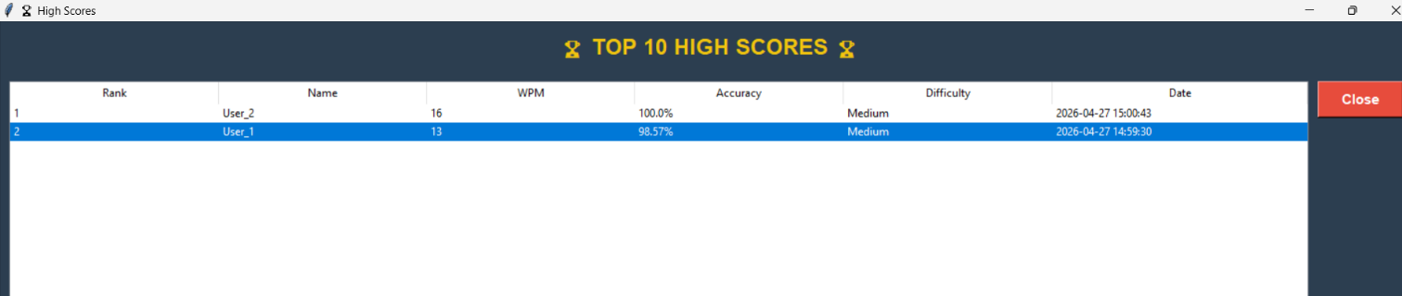
Output:

# Main execution
if __name__ == "__main__":
root = tk.Tk()
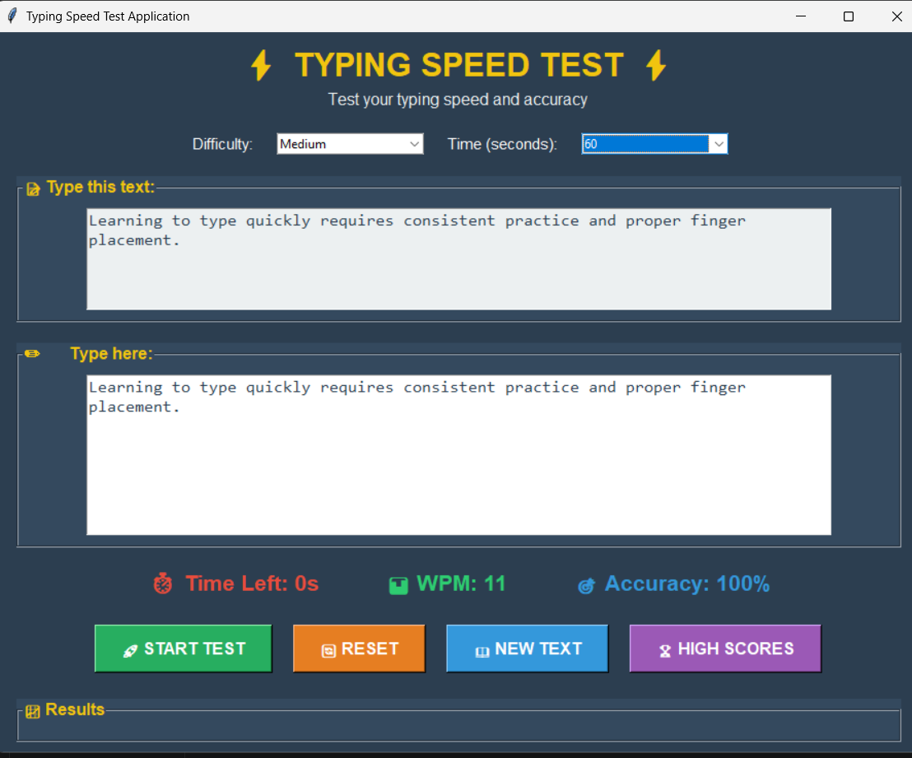
app = TypingSpeedTest(root)
root.mainloop()

